LIBRARY MANAGEMENT SYSTEM

* **CLASS DIAGRAM**

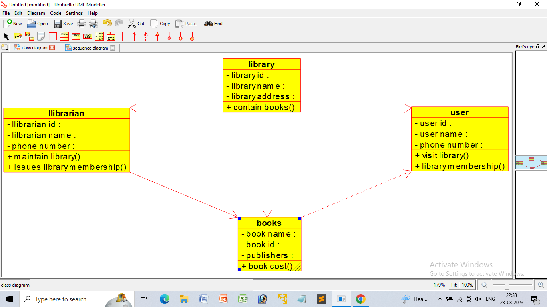

* **USE CASE DIAGRAM**

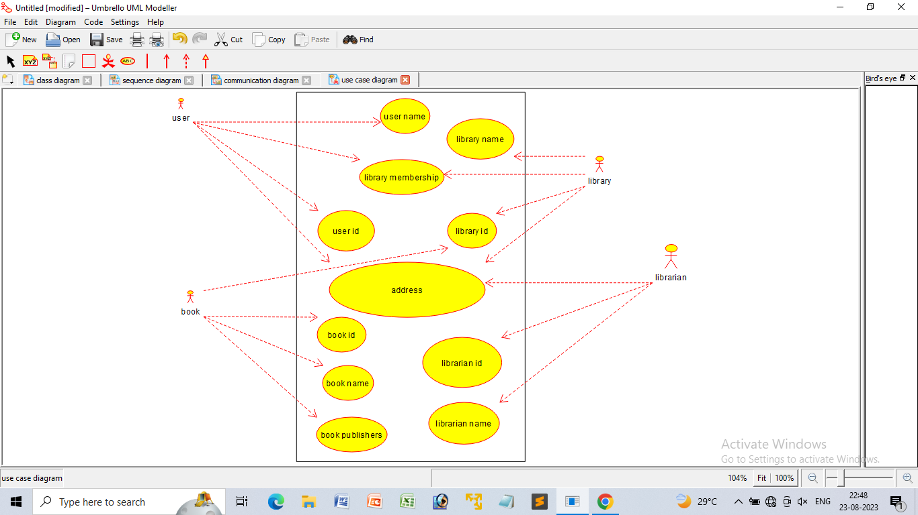

* **ACTIVITY DIAGRAM**

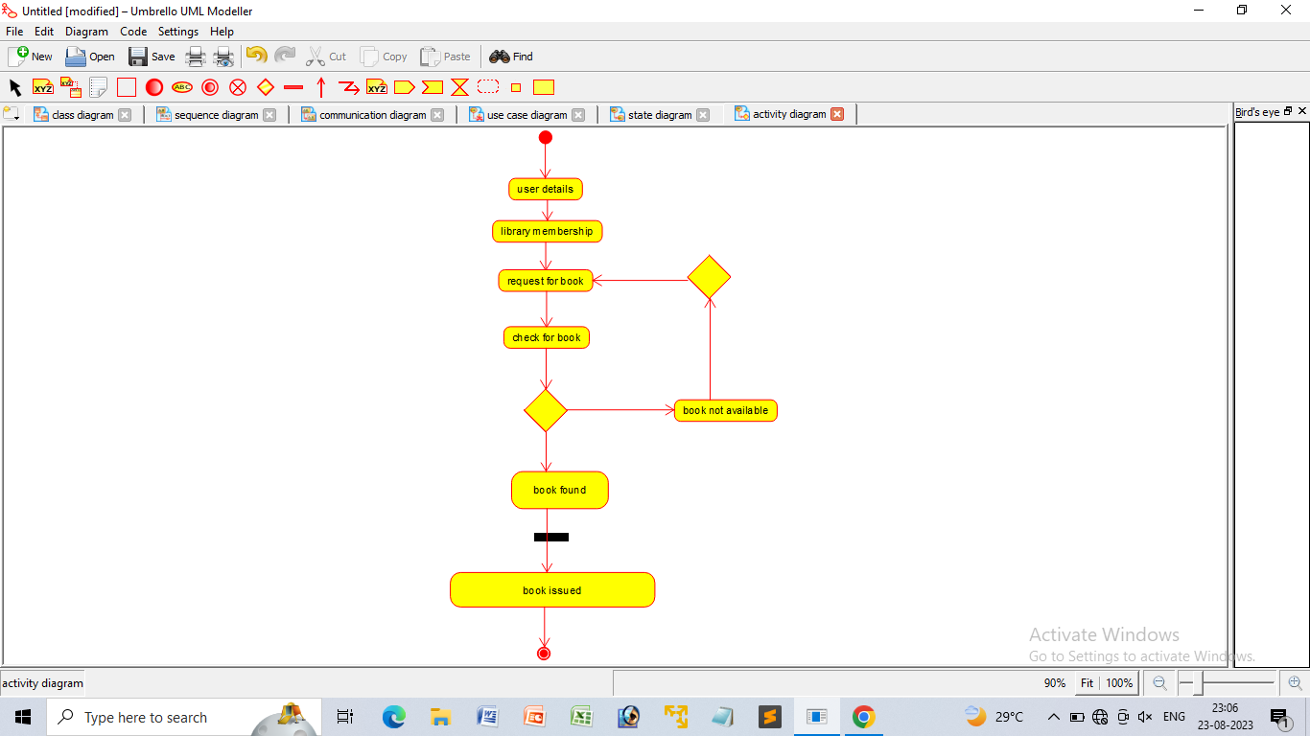

* **STATE CHART DIAGRAM**

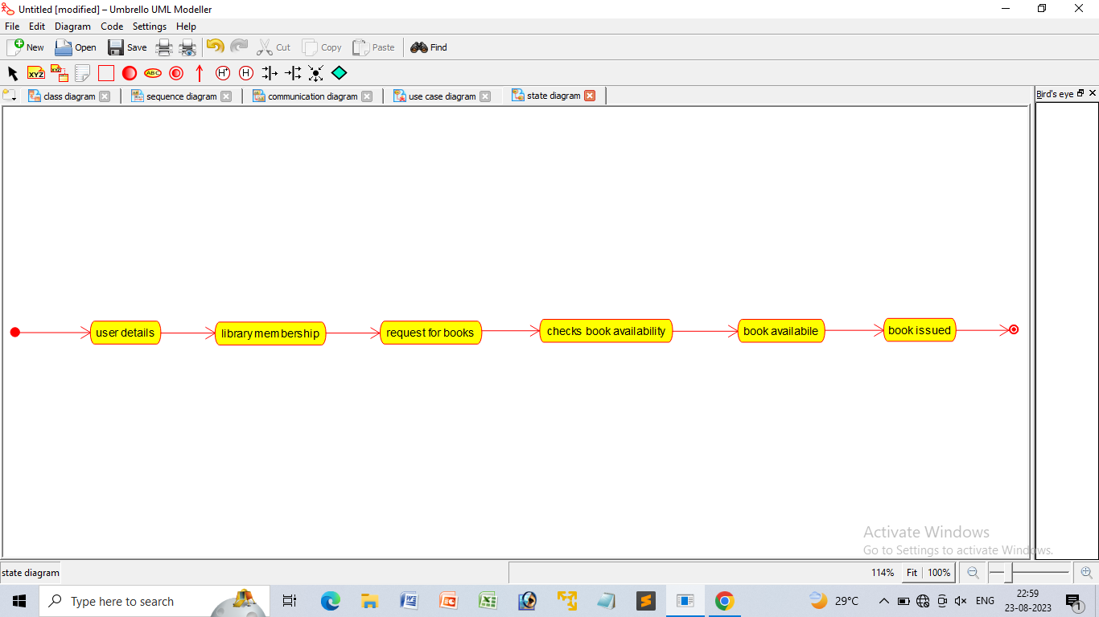

* **SEQUENCE DIAGRAM**

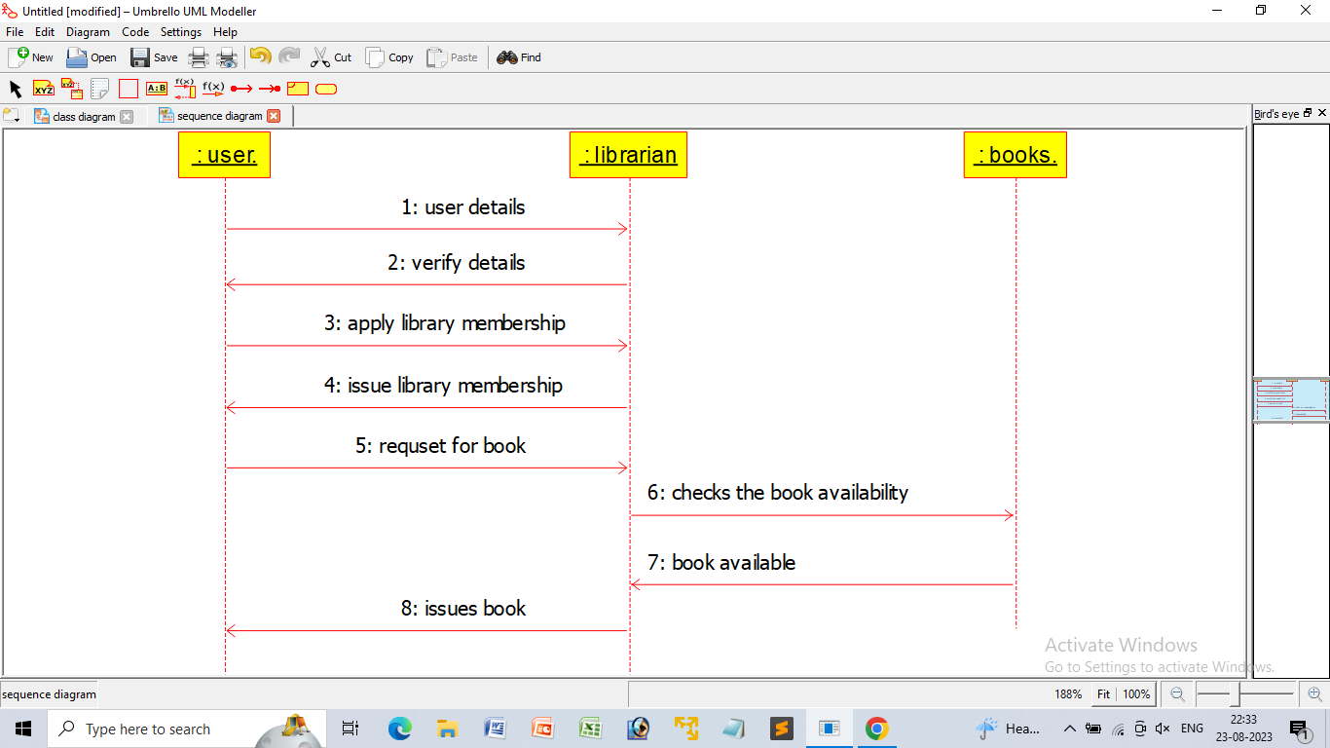

* **COMMUNICATION DIAGRAM**

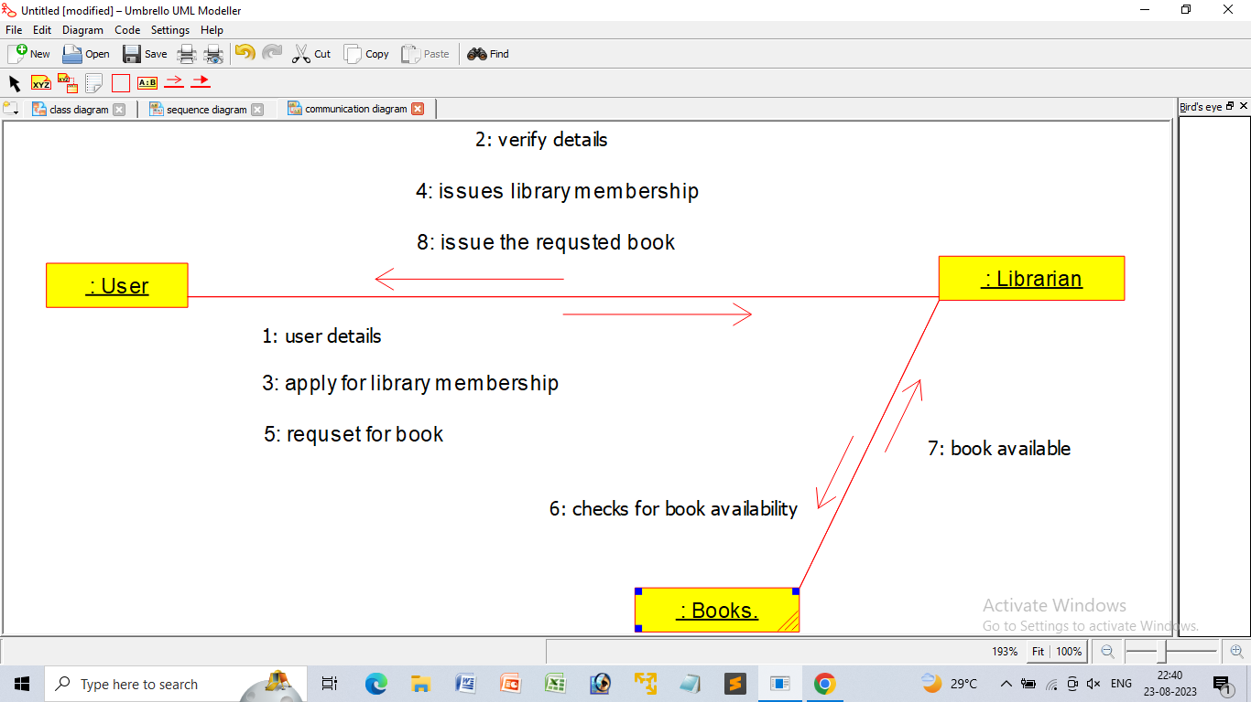

* **COMPONENT DIAGRAM**

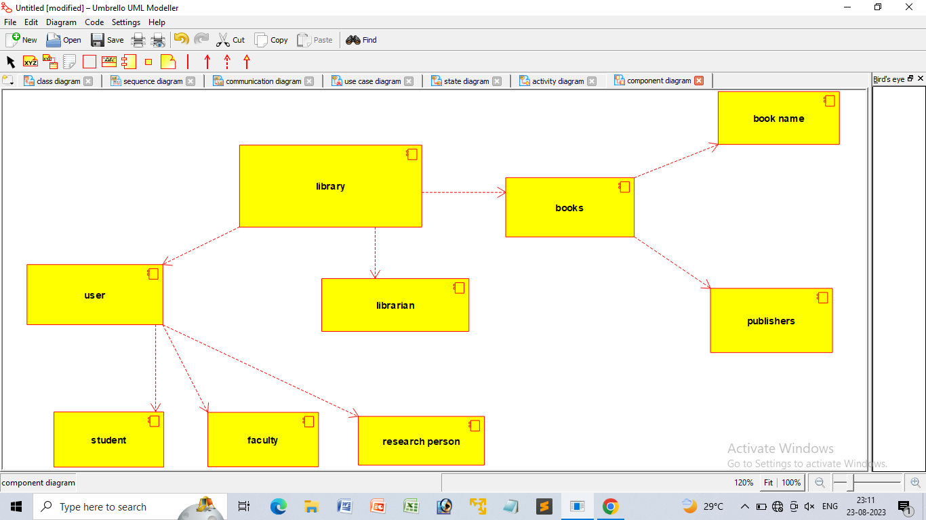

* **PACKAGE DIAGRAM**

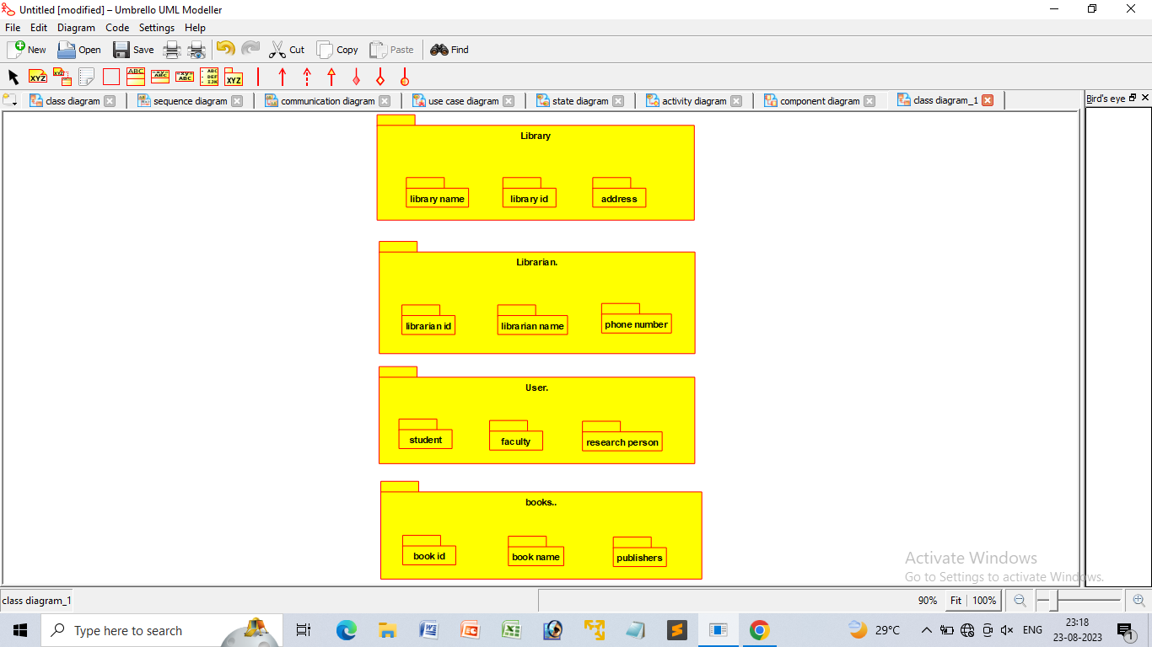

* **DEPLYOMENT DIAGRAM**

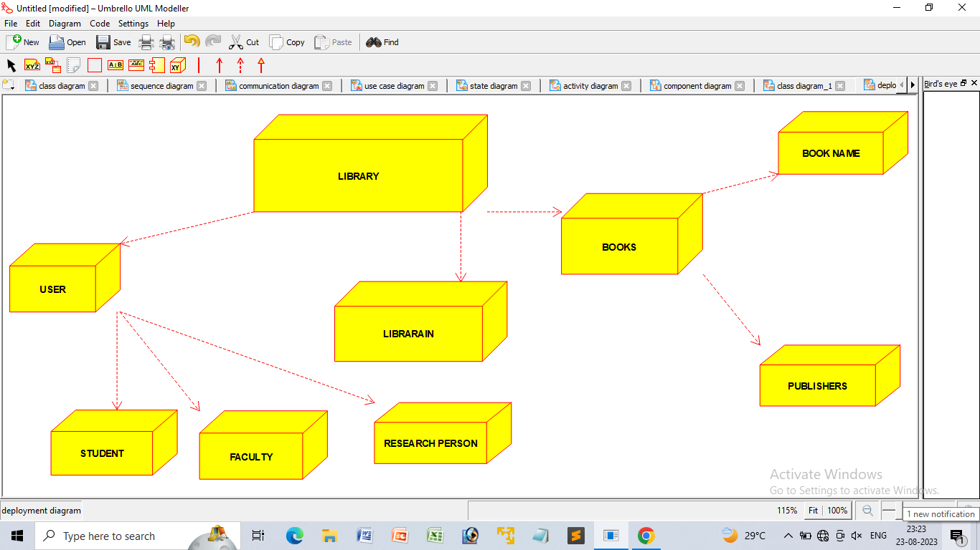

* **PROGRAM**

